CROATIAN PHYSIOLOGICAL SOCIETY
Šalata 3B, 10 000 Zagreb
contact: aleksandra.dugandzic@mef.hr
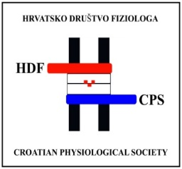
Registration Form
For the 16th Annual symposium of the Croatian Physiological Society with international participation (September 28 – 30, 2023)
Personal information
Name:
Surname:
Title:
Institution:
Country:
Address:
E-mail:
Registration (Please mark the preferred option)
I would like to register:
- As member of the Croatian Physiological Society
* Registration fee is waived
- As non-member of the Croatian Physiological Society
* Registration fee: 25,00 €
I will bring an accompanying person:
- Yes
- No
* Please note that if the accompanying person are non-members, they will also need to pay the registration fee
Participation
Please select preferred type of participation in the conference:
- Oral presentation
- Poster presentation
- Passive participation

I give my consent for publishing my abstract online (Yes/No)?

Conference dinner, September 29th, 2023 (Friday) (place TBA)
  - Yes
  - Yes - accompanying person
  - No

Field trip, September 30th, 2023 (Saturday)
Location: Vukovar Watertower (https://vukovarskivodotoranj.hr/en/home/) and Museum Vučedol culture (https://vucedol.hr/); restaurant for lunch TBA.
* Included is a fee for lunch and travel expenses up to 30.00 €).
- Yes
- Yes - accompanying person
- No

Allergies and dietary restrictions
If you have any food-related allergies or dietary restrictions, please list them and we will do our best to accommodate them. If you are bringing an accompanying person, please note their allergies as well.
Allergies: ______________________________________________________
Dietary restrictions: ______________________________________________

Date: Signature:

